**Supplementary Figure 1. Morphine distribution channel in Nepal**

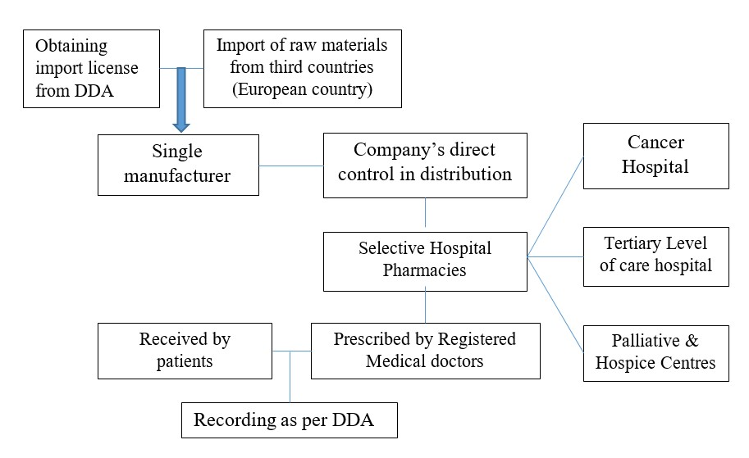

**Supplementary Figure 2. Retailer’s Narcotic and Psychotropic Record form (extracted from Department of Drug Administration website)**1

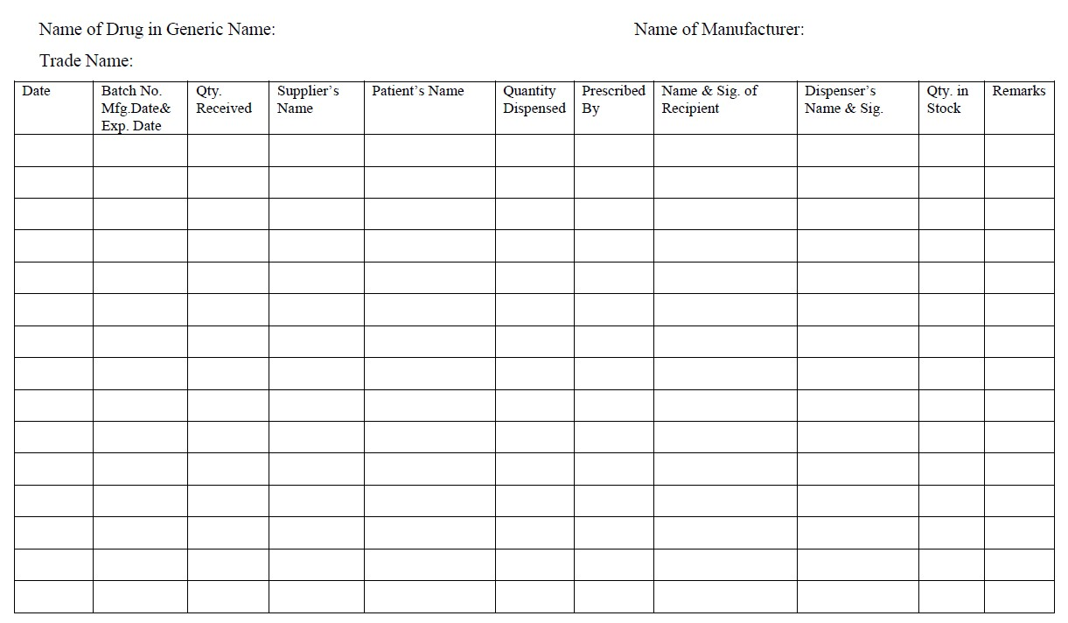

**Reference**

1. Department of Drug Administration. *Narcotic and Psychotropic Drugs*.; 2018. https://www.dda.gov.np/content/narcotic-and-psychotropic-drugs